DSpace Global Change
The steps to globally change the values for the metadata field are listed below:
- Click on the admin tool in the menu.

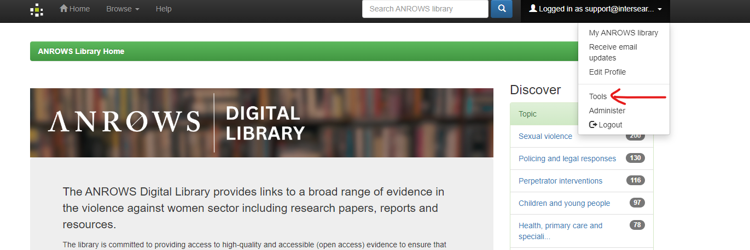

- Once you log in to the admin section, navigate to the Tools and click on global Change. (../admin/admin_dspaceglobalchange.php)
- Select an element and section you wish to change

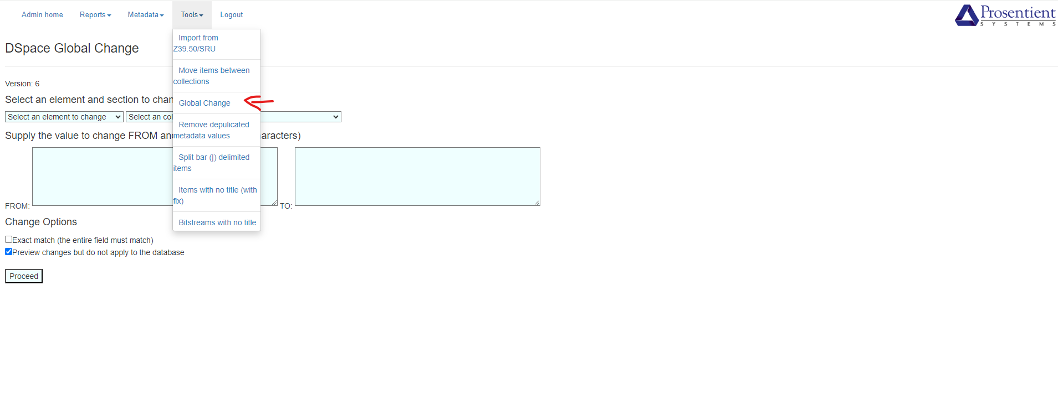

- Select an element and section you wish to change
- Supply the value to change FROM and TO (minimum 3 characters)
- You can always preview the changes before you proceed with the modifications. Please follow the screenshot attached.
