SELF REGISTRATION EXERCISE FOR DSPACE
LOG INTO DSPACE
- In your web browser type in the address of the elibrary (eg docs.prosentient.com.au)  - Click on the My DSpace link (this could be different on your site – eg My eLibrary)  - Click on the New user? Click here to register link  - Fill in your email address and click the REGISTER button | 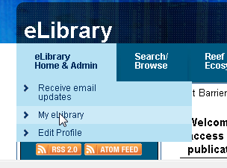  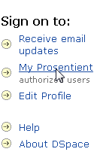    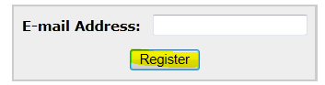
CONFIRM YOUR REGISTRATION
- You should receive an email with a registration confirmation link. Check your junk mail folder if you do not see it in your inbox.  - Click on the link in the email and fill out the form with your Name and Password and click REGISTER | 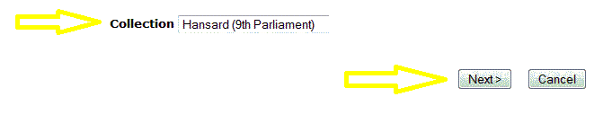
ALERTING SERVICE
As a registered member, DSpace can send you an email alert when new documents are added to a collection that you are interested in.  - Click Communities and collections  - Click on the collection for which you want alerts  - Click on the subscribe button on the bottom right-hand side.  - If you are not already logged in you may be asked to provide your email and password | 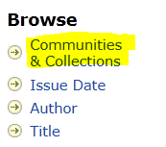  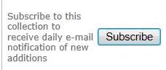
SUBMITTING DOCUMENTS
Contact the library or email the DSpace eLibrary contact to be granted access to collections in the eLibrary. | Tips: obtain the 1 page quick guide to completing submissions.

